# Calibration Tool SOP

## Introduction

The purpose of the calibration tool is to convert pixel density into real-world dimensions. Calibration is essential whenever a new cyst body distance relative to the camera is introduced. This process involves using a NIST-calibrated dot array with 250 µm spacing.

The calibration procedure is as follows:

Capture an image of the dot array using the back camera.

Extract pixel luminosity and distance data using the Tracker software.

Paste the extracted data into the "Calibration Tool" Excel spreadsheet.

The spreadsheet automatically calculates the pixel/mm ratio, along with accuracy and precision metrics. This pixel/mm ratio is subsequently used to measure the distance between fenestration points and bead locations accurately.

#### Step 1: Capture image using dot array

Obtain aquarium, calibration cyst body, and 250um dot array. Slide the dot array into the calibration body with test facing toward camera. Note, installing the calibration grid backwards will result in a 1mm distance error between cyst-membrane to camera. Install the calibration cyst body onto the aquarium. See Fig.1 below.

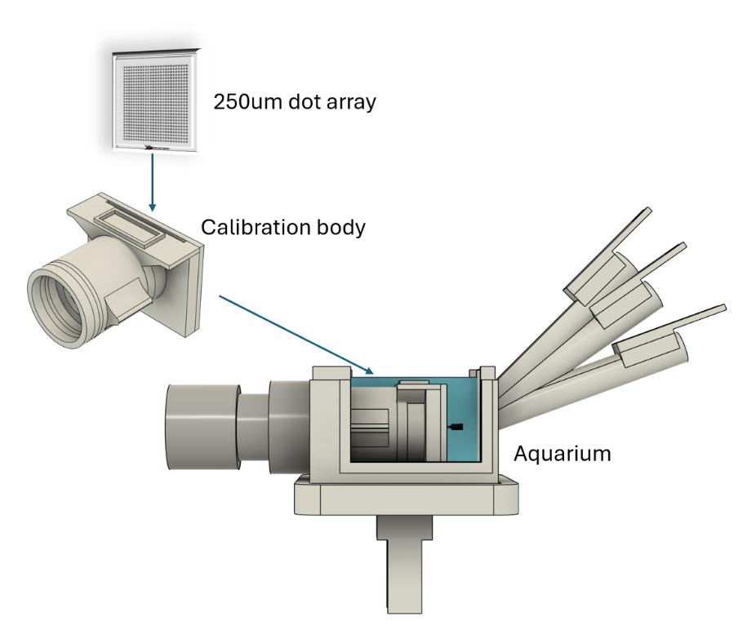

Figure 01. Assembly of aquarium, calibration body, and dot array.

#### Step 2: capture image of dot array

Open the camera app for you PC and set the camera pixel resolution to 5mp (2582x1944). Turn on crosshair and align dot array to be parallel. Note that if this is not possible, then dot array alignment can be achieved in Step 3 using Tracker software. Once crosshairs and dot array are aligned, turn off cross hair framing grid and capture image of dot array. See Fig.2 below. Be sure to adjust the lighting such that the dot array is well contrasted with the background. You might need to turn off camera lighting by adjusting wheel near USB port on camera cable. Use an external light to scatter light through glass slide on top as needed.

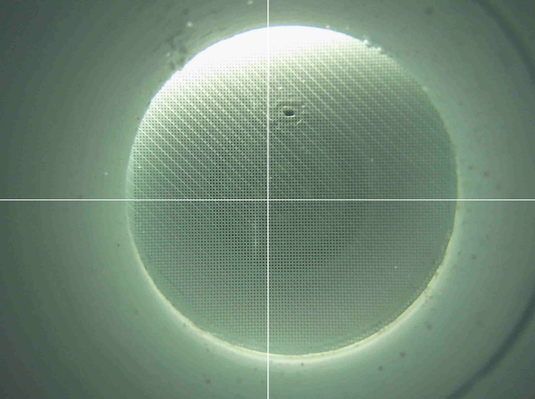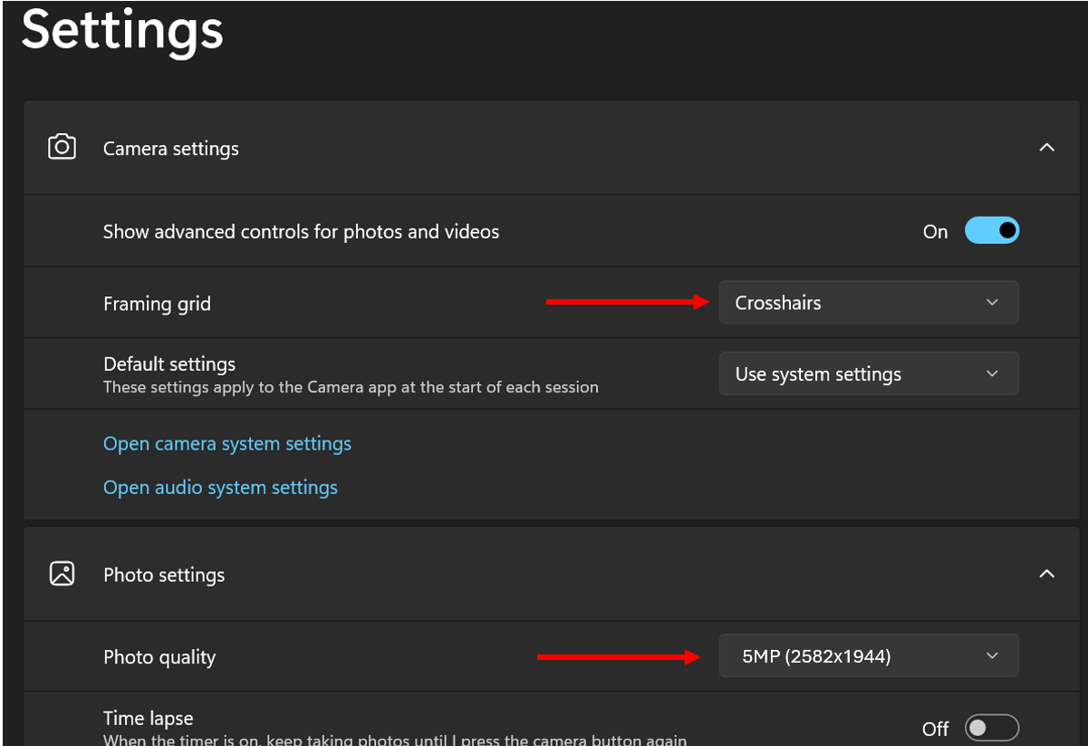

Figure 02a. Example of camera settings using Microsoft camera app.

Figure 02b. Crosshair framing aligned with dot array grid.

#### Step 3: Calibration with Tracker software

You will need to download the tracker software or retrieve it from GITHUB. Please find links below:

1. Tracker software: <https://tracker.physlets.org/>
2. GITHUB: <https://github.com/PABionaut/AccuracyMeasurement>

Open Tracker software and upload the image of the dot array. This can be done by dragging the image directly from file location into Tracker window. Find the calibration stick as shown in Fig.3 below:

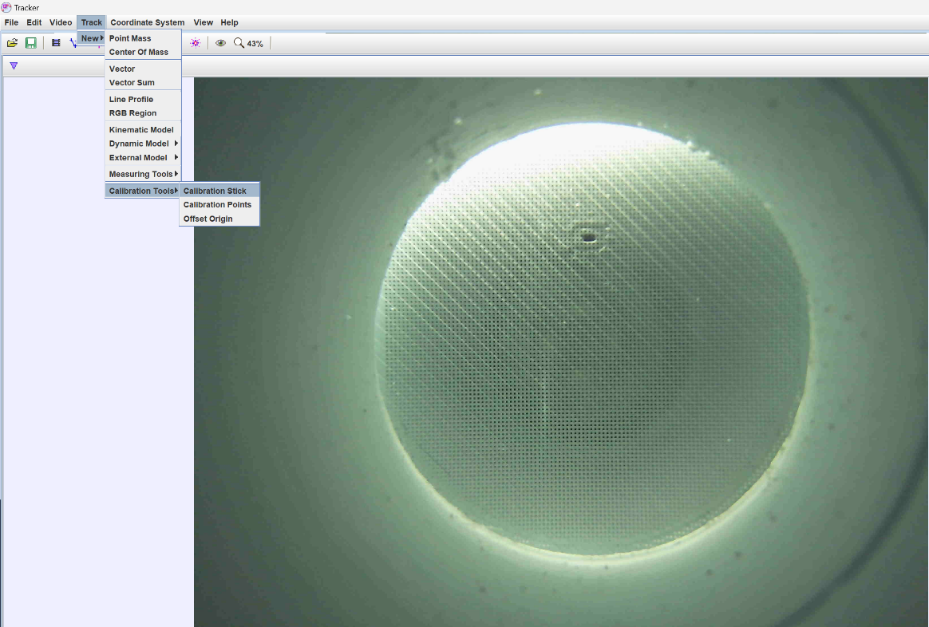

Figure 03. Create calibration stick: Track>new>calibration tools>calibration stick

Zoom in the dot array, and place the calibration stick 5 dots apart (0mm, 0.25mm, 0.50mm, 0.75mm, 1mm). Navigate to top tool bar and select *coordinate system > units*. Replace m with mm. See Fig4ab.

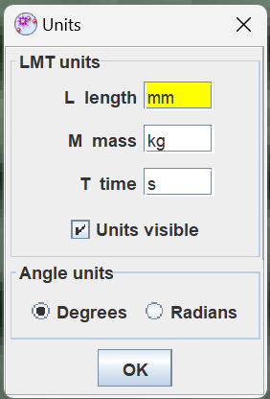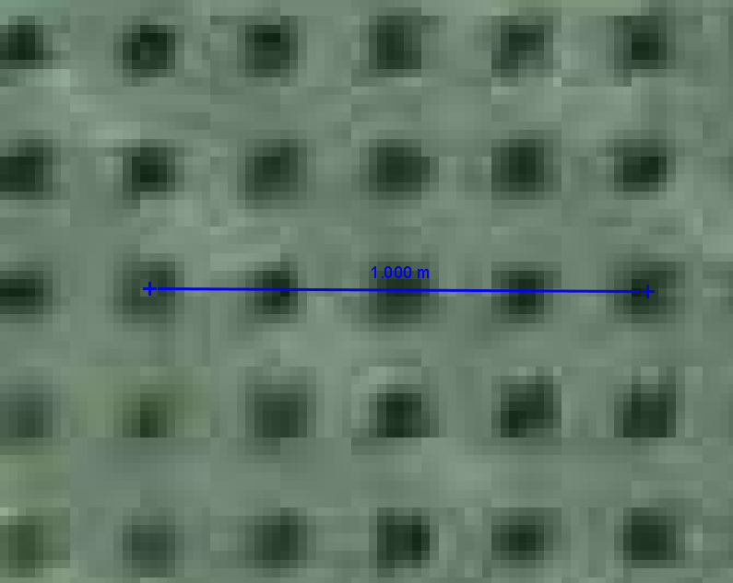

Figure 04a. Place calibration stick between 5 dot arrays equating to 1mm. Be sure to center the calibration stick with the dot center.

Figure 04b. Change the units from m to mm. coordinate system > units

Now input an axis near the center of the grid. Exact positioning is not important. This will be used to reference pixel data to a defined position.

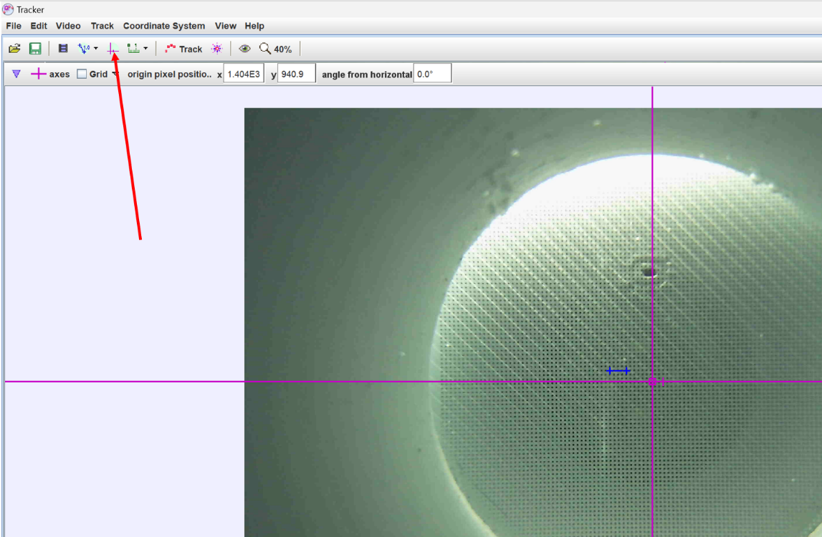

Figure 05. Input of coordinate system in image.

Next, input a line profile by going to *Tracker > new > line profile (Fig 6).* Note, if the data in the line profile is not contrasted enough, you will need to convert the image to black and white and adjust the threshold to create high contrast between dot array and pixel. This is done using external software of users choosing. From this point forward, the image was adjusted to black and white. See Fig 7 below; notice the dot line profile produces high contrast waveform where pixel luminosity is nearly binary and oscillating from 0 LUMA to 255 LUMA.

Figure 06. Create a line profile.

Figure 07. Stretch the line profile across 8mm of dot array (at least 41 dots). Use measuring tape to quickly measure 8mm Track > new > measuring tape. Note that the plot in upper right shows waveform that oscillates with binary amplitude (trough 0 LUMA, peak 255 LUMA). This is achieved by converting image to black and white.

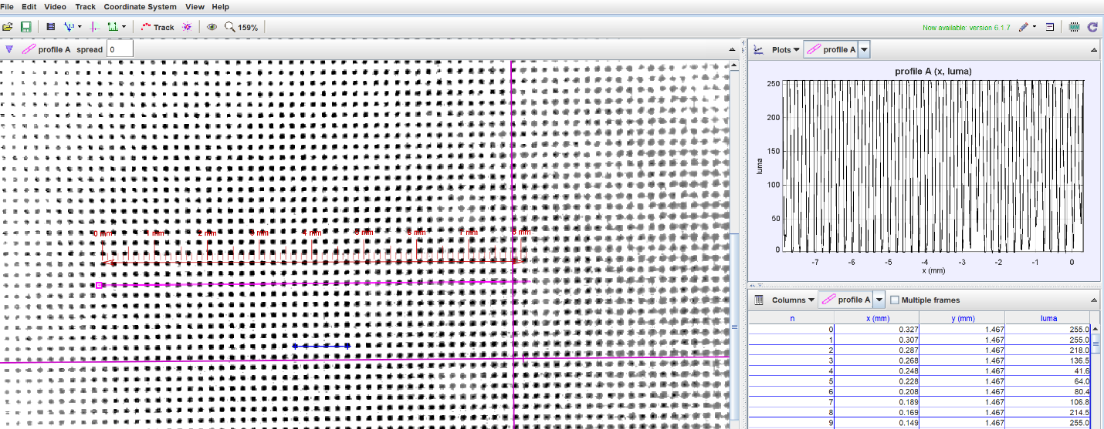

Lastly, go to *file > export > data* and be sure that n,x,y,luma are selected (see Fig 8). Copy this data to the clip board.

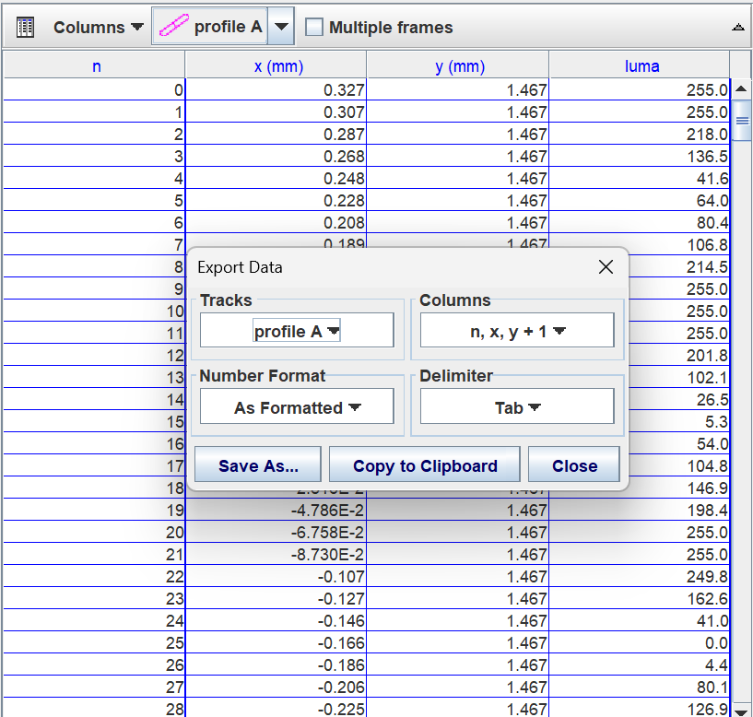

Figure 08. Screen shot of data to be copied to clip board.

#### Step 4: Calibration tool

Open Calibration tool excel file (found in GITHUB). Copy the data from the Tracker file into cell A3 and let the rest of the column populate on their own. Be sure that the accuracy and precision are within 10%. If not, (1) check calibration stick for correct calibration. (2) Check the waveform in tracker and adjust as needed in F column to set threshold. (3) check that the newly copied data array isn’t overlapped with old data in columns A-D. Once accuracy and precision are below 10%, Take note of the Pixel/mm value in cell Q5. This will be the pixel-distance transformation.

